**LAB REPORT : EXPERIMENT 2.2**

**Date: 24th August 2021**

**Name: Rita Abani**

**Roll No: 19244**

**Title of Experiments:** A) Charging and discharging characteristics of capacitor using DC source.

                        B) Effect on the output of RC circuit for a square wave input signal with duty cycle 1/3 and 2/3 (Duty cycle= ON time/ Time period).

**Brief Description:**

In this experiment we simulate two scenarios on the LTSpice circuit Simulator for Objective A and Objective B as listed above. For objective A, we simulate 4 cases , i.e 2 with constant resistances and varying capacitance while other 2 vice versa. We do the same with the discharging case and observe a symmetry. While simulating the circuit, we start external DC supply voltage at 0V.

For Objective B, we perform something similar to what we did in Exp 2.1 , but here we vary the duty cycle and observe the effects on the Waveforms. We first simulated the circuit for a duty cycle of 1/3 and then with a duty cycle of 2/3 to monitor the output wave pulses. These two cases were done with a transient of 5T.

.

**Schematic diagram:**

For Part A:

Let us first consider the Charging and Discharging characteristics of the capacitor using DC source, so this is divided into two separate cases

|  |  |  |  |
| --- | --- | --- | --- |
| S.NO | Resistance (in Kilo Ohms) | Capacitance (in Micro Farad) | Time Constant (in Kilo Ohms Micro Farad) |
| 1 | 10 | 10 | 100 |
| 2 | 10 | 1 | 10 |
| 3 | 5 | 10 | 50 |
| 4 | 15 | 10 | 150 |

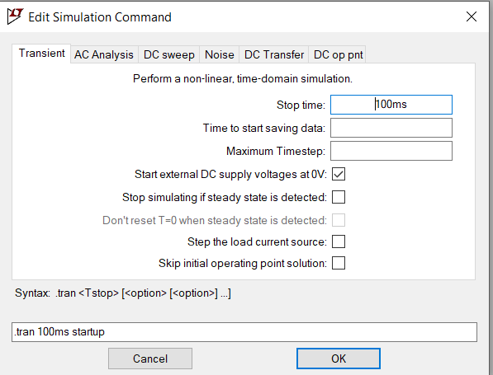

**Case 1: When Resistance is constant = 10Kohms and capacitance is varied**

**Case a: Capacitance = 10 Micro Farad**

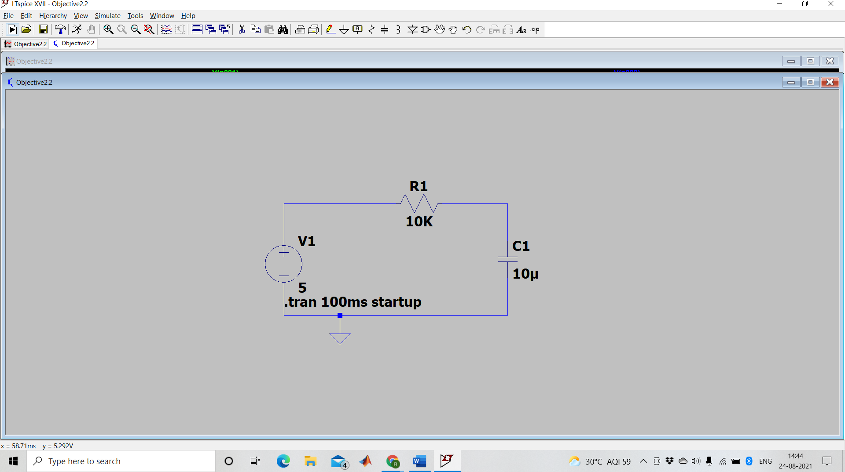

**Case b: Capacitance = 1 Micro Farad**

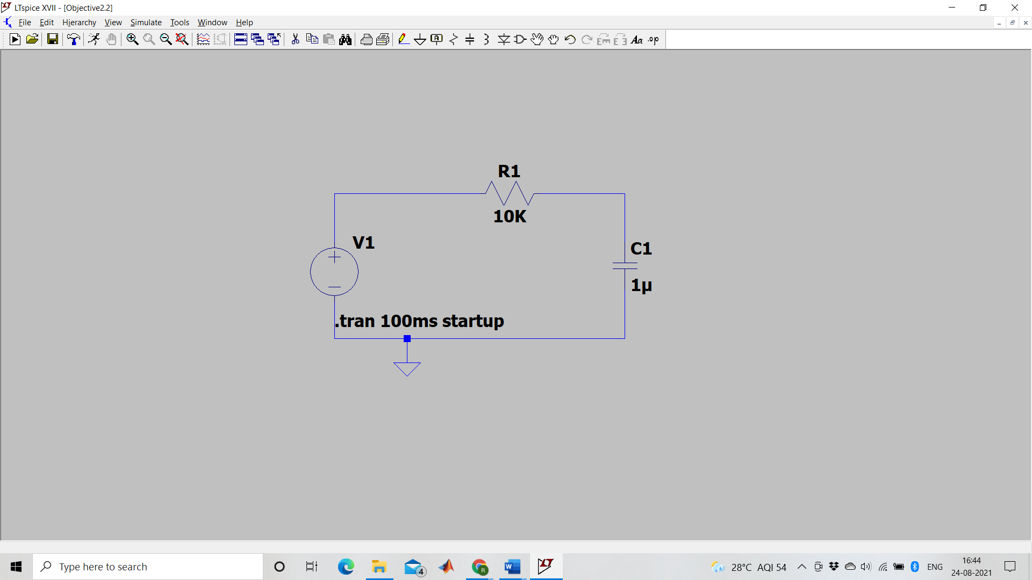

**Case 2: Capacitance is constant at 10 Micro Farad while resistance is varied**

**Case a: Resistance, R= 5K Ohms**

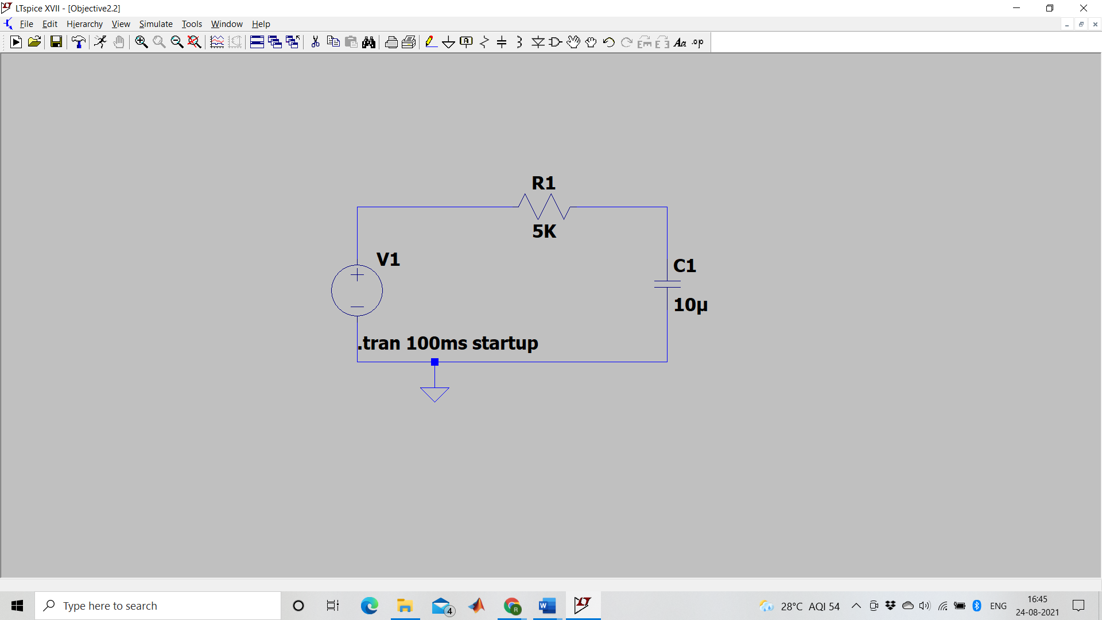

**Case b: Resistance, R= 15K Ohms**

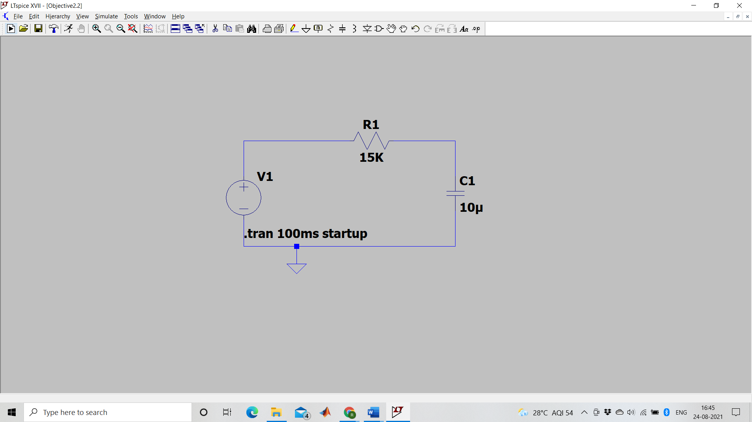

**Objective B**

**The following were the parameters considered:**

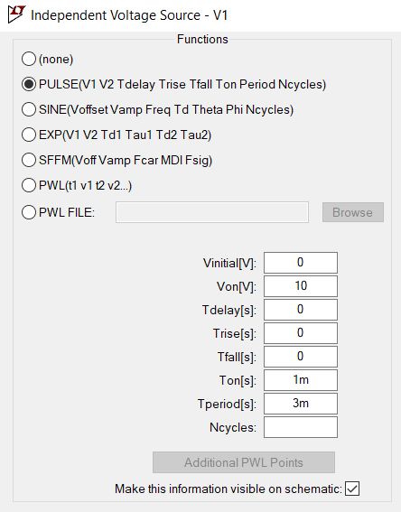

The following table summarizes the same:

**For a transient of 5T**

|  |  |  |  |  |  |
| --- | --- | --- | --- | --- | --- |
| Resistance (in kilo ohms) | Capacitance (in micro farad) | T(on) in seconds | T(period) in seconds | Duty Cycle = T(on)/T(period) | Time Constant=R*C in kilo ohms micro farad |
| 1 | 1 | 1m | 3m | 1/3 | 1 |
| 1 | 1 | 2m | 3m | 2/3 | 1 |

**Case 1 schematic :**

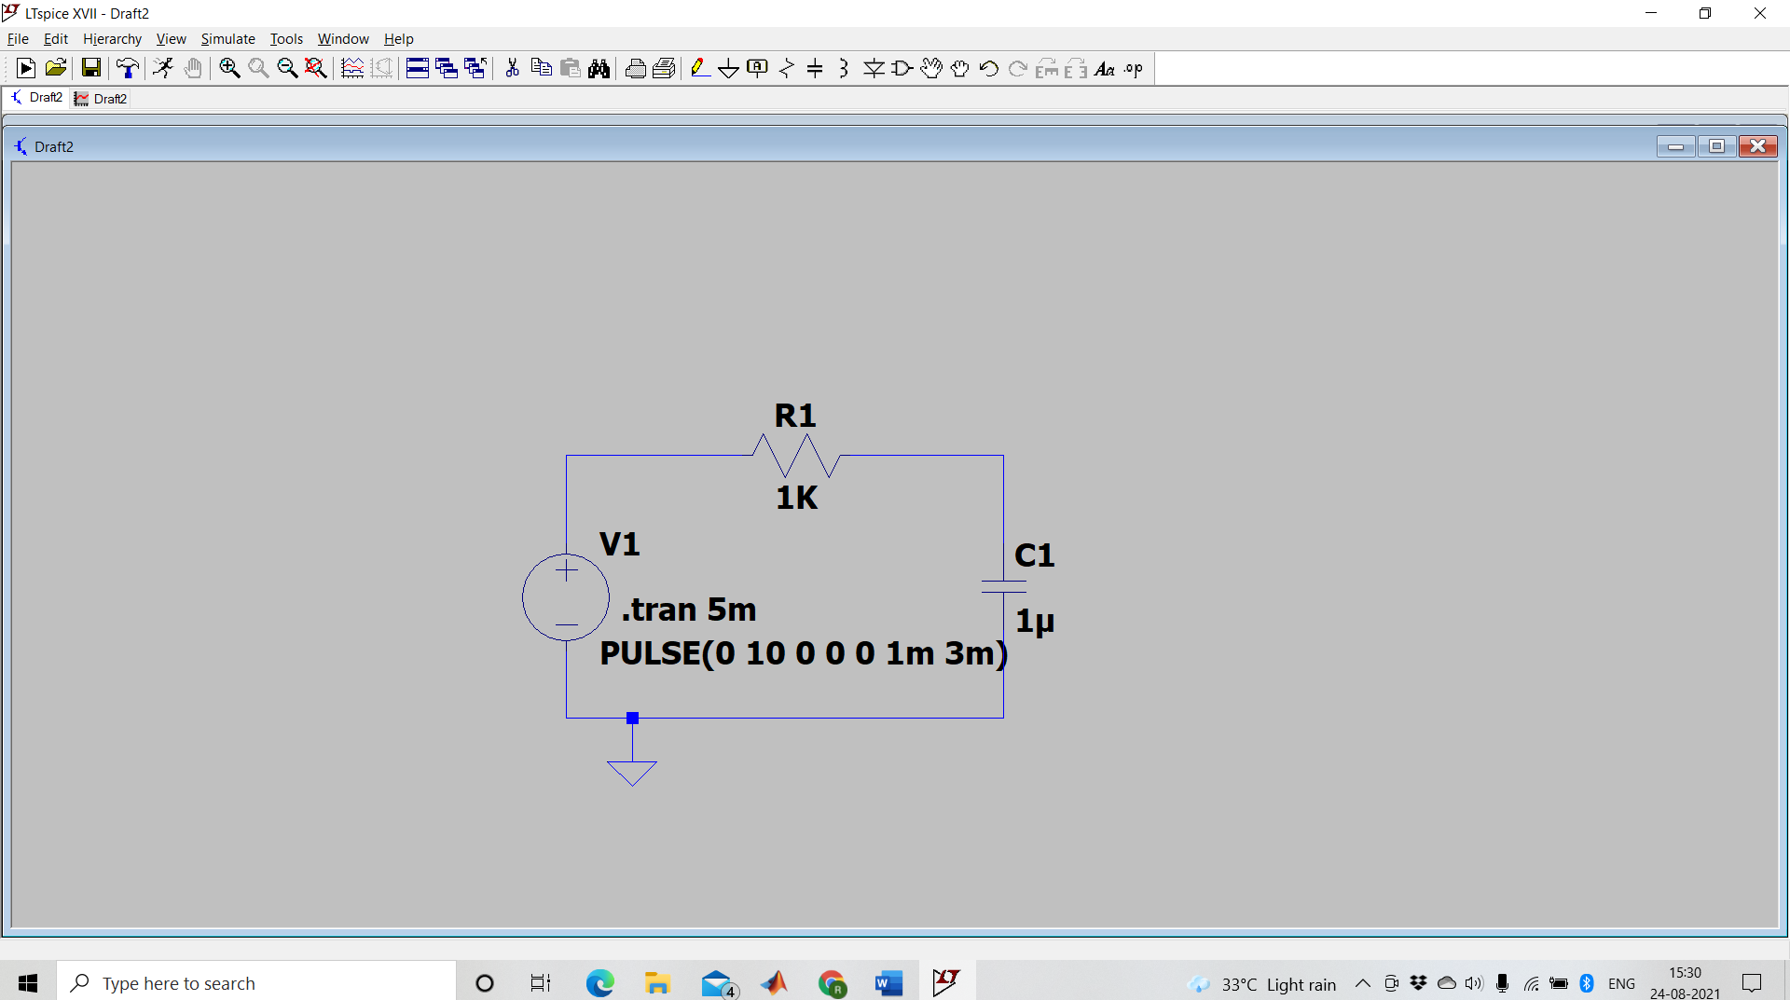

**Case 2 schematic:**

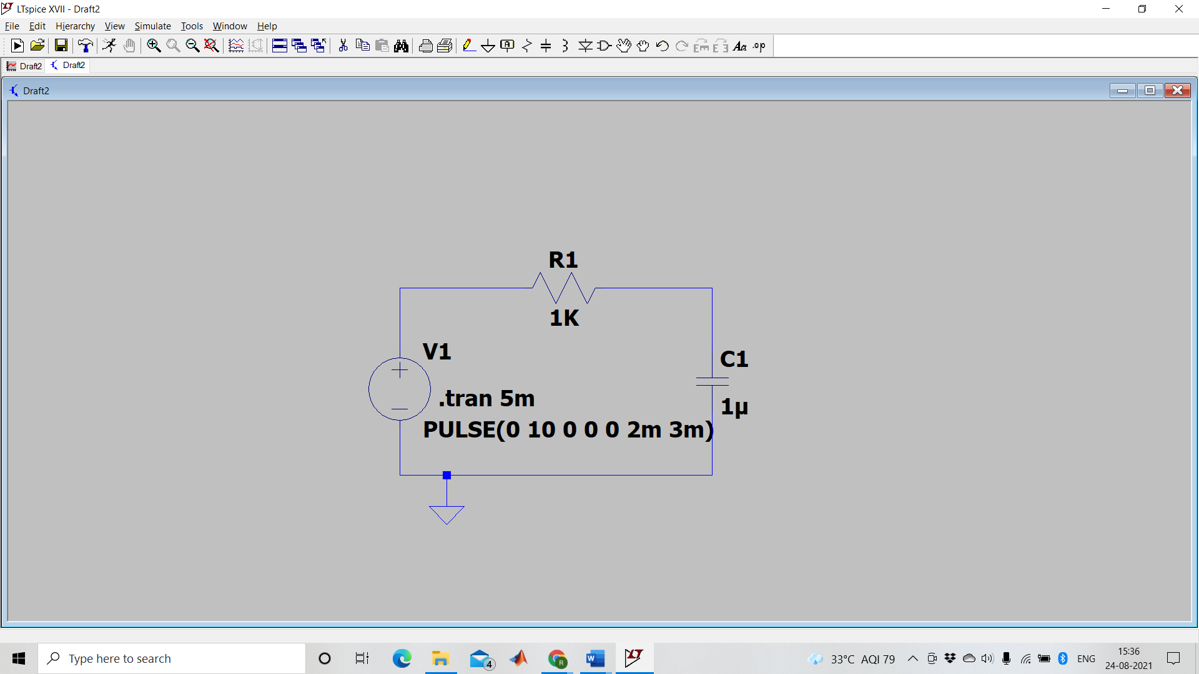

**Results :**

**The Resultant waveforms with the associated circuits in the order of schematics is shown below :**

**For Objective A:**

**Case 1a:**

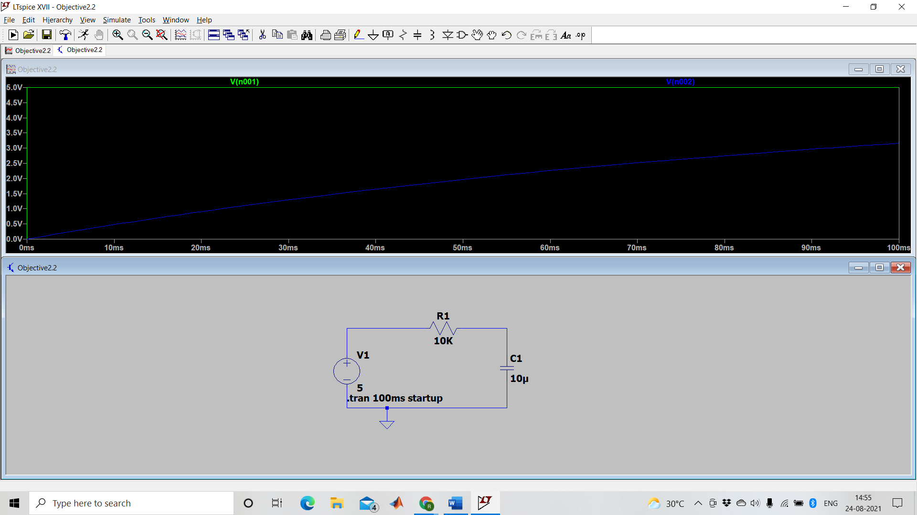

Case 1b:

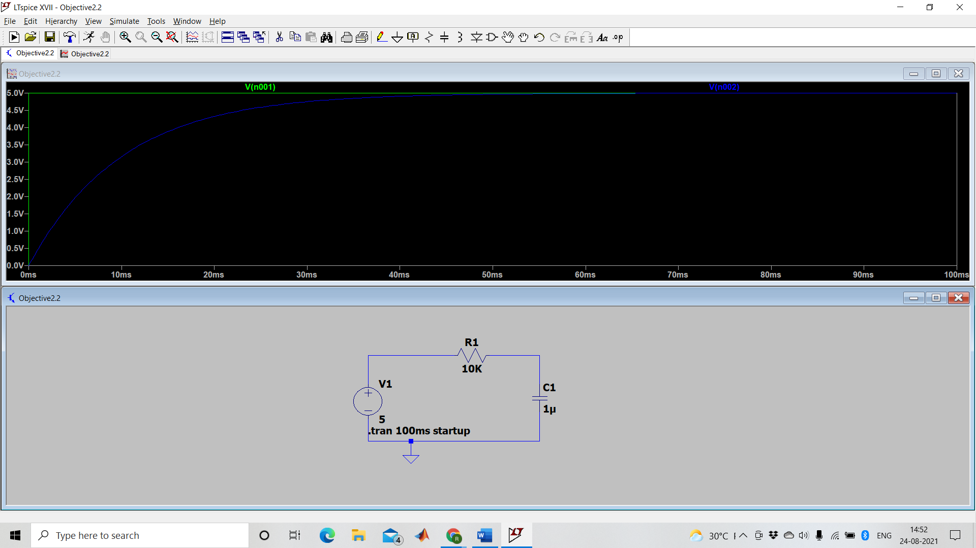

Case 2a:

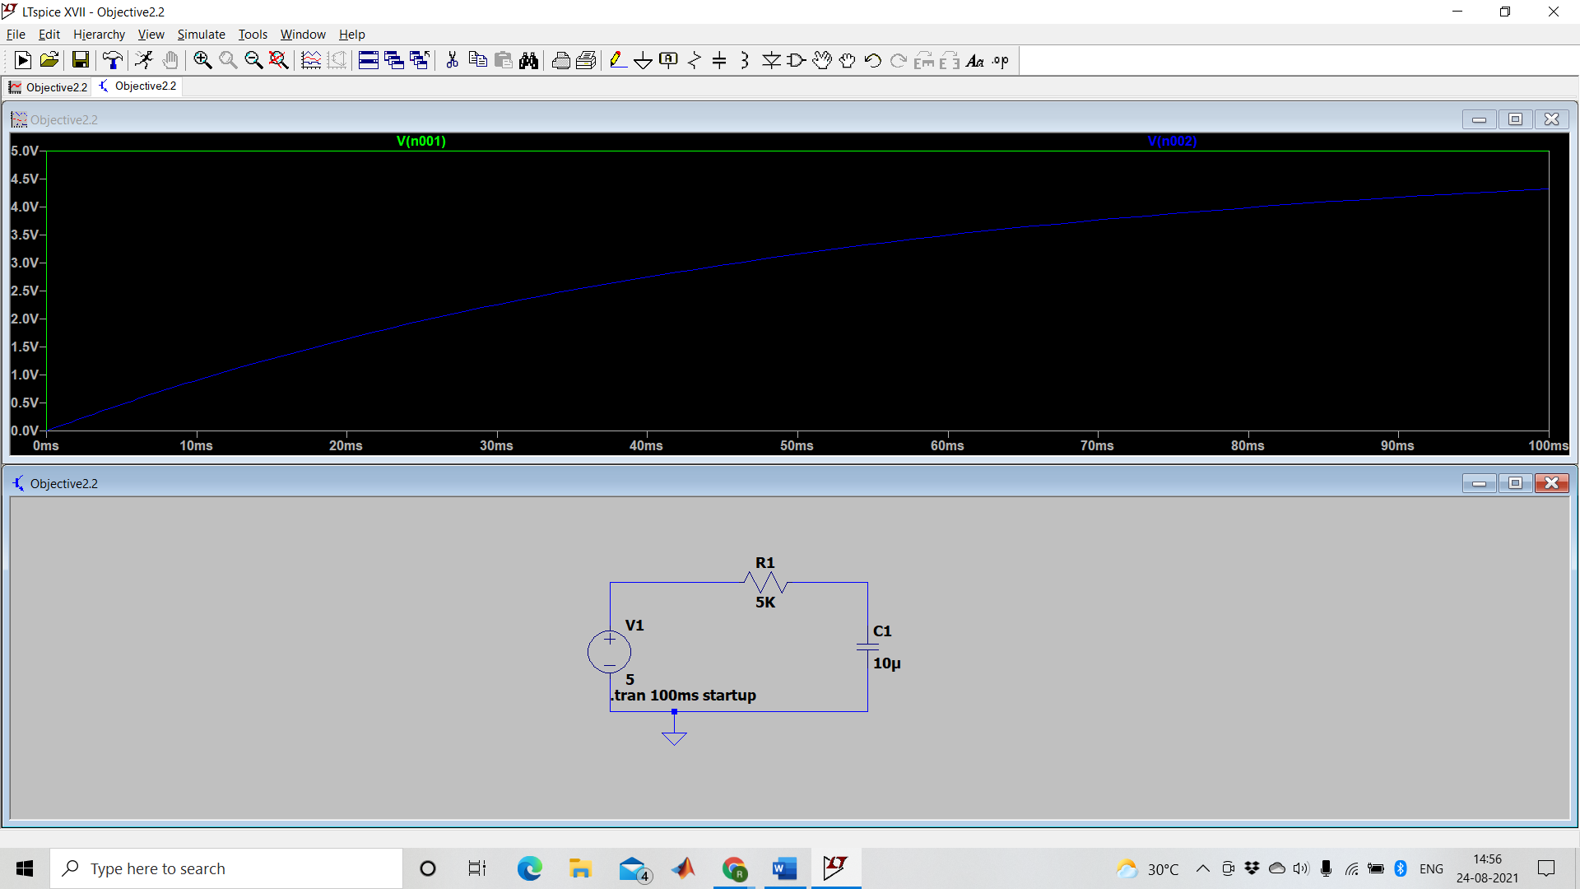

Case 2b:

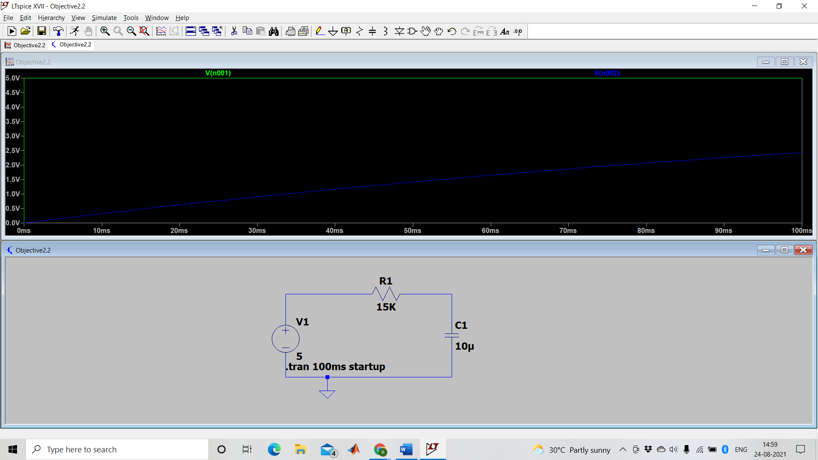

In case of discharging, we would see identical waveforms in the opposite directions as seen in the charging case conserving symmetry of charges.

The charging and discharging of capacitor generally takes time and depends on the time constant (τ) of the circuit, i.e R*C (it can be seen in the table above for our cases).

**Objective B:**

**1)For a duty cycle of 1/3, the waveform and the associated circuit are shown below:**

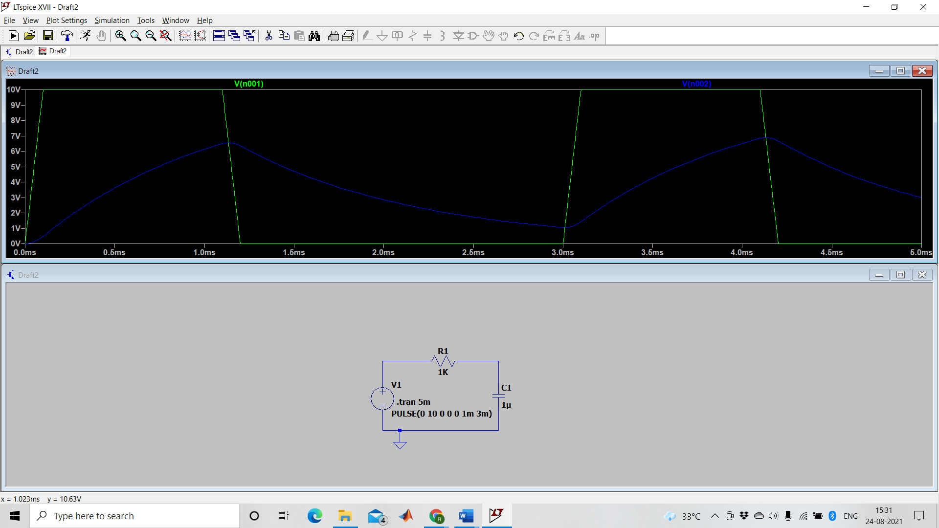

2)For a duty cycle of 2/3, the waveform and the associated circuit are shown below:

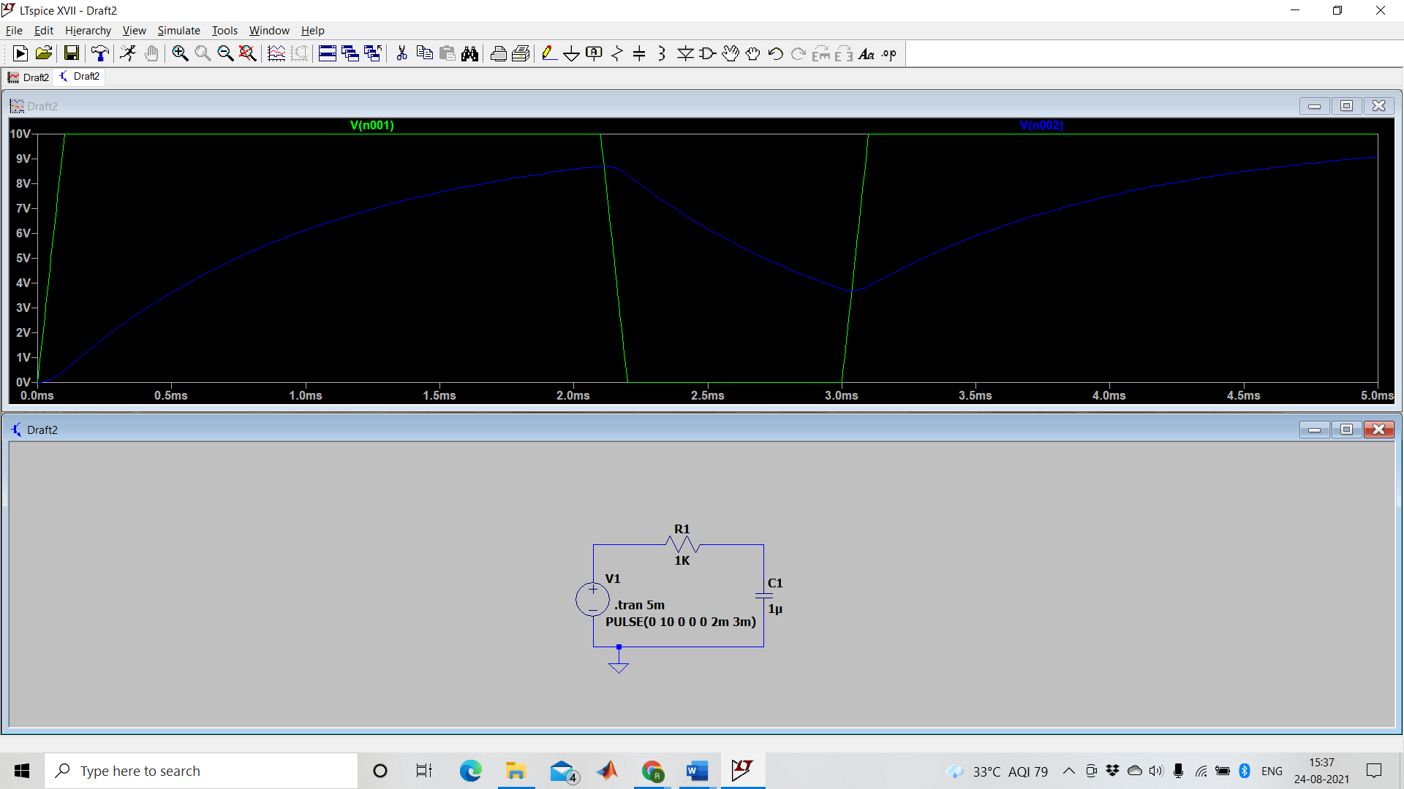

**Discussion:**

A discharged capacitor connected to a DC voltage source charges up with increase in the voltage of the source. Similarly, a charged capacitor discharges in opposite direction when the applied voltage of the DC source is reduced. We made use of this fact while simulating our circuits.

We can infer that at T=5T in Objective B, the capacitor becomes 100% charged. We can calculate that for 4T the capacitor is 98% charged and so on. The time before this is the transient period and t>4T is known as the steady state where T=5T as the capacitor can be treated as a fully charged one. The exact opposite happens in discharging, instead of charging upto 5V , we are instead starting from 0 and starting to charge until -5V (i.e charging in the opposite direction).

In case of a square wave input, the voltage will be high for a certain period of time and zero for a certain period of time consecutively. Hence we can say that a square wave is a constant DC current source for a specific time period. At any time period below 5T, for high or even 0 voltage will lead to a distorted or nearly equivalent triangular wave at the output across the capacitor.